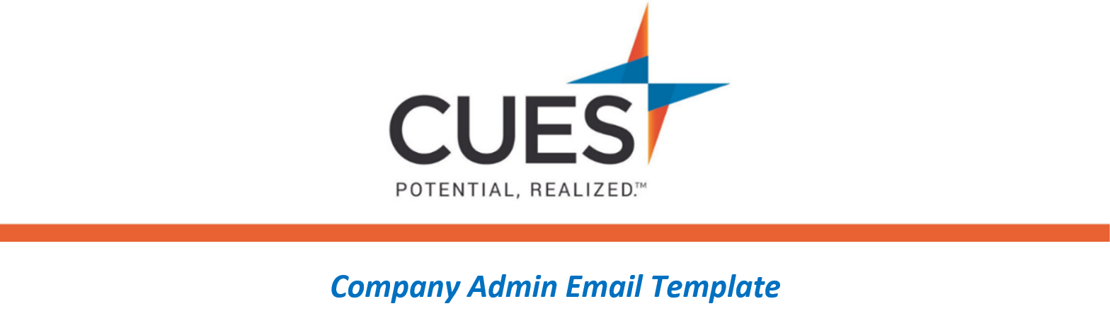
CUES Reminder – 1 month out

Purpose: Send one (1) month after the welcome emails are sent from CUES
Directions: Copy and paste the template below into a new email, replace all highlighted fields, then send

SUBJECT: Don’t forget about your CUES Membership!
Hello Team,
As part of your ongoing professional development, <CU/ORGANIZATION NAME> has invested in you! A month ago, you were granted access into the Unlimited(+) membership with CUES. You should have received a welcome email and logged in to cues.org by now. The <COURSE NAME> course was shared to you, with a due date of <DUE DATE>. Please be sure to login and complete the course before the due date.
If you are interested in additional learning opportunities, review the content catalogs below:
CUES Learning Portal Content Catalog
Harvard ManageMentor Catalog
Be sure to check out the CUES Member Help Center to find additional resources within your membership.
If you have trouble accessing CUES, please contact them right away at 608.271.2664 opt. 2 or cues@cues.org.

