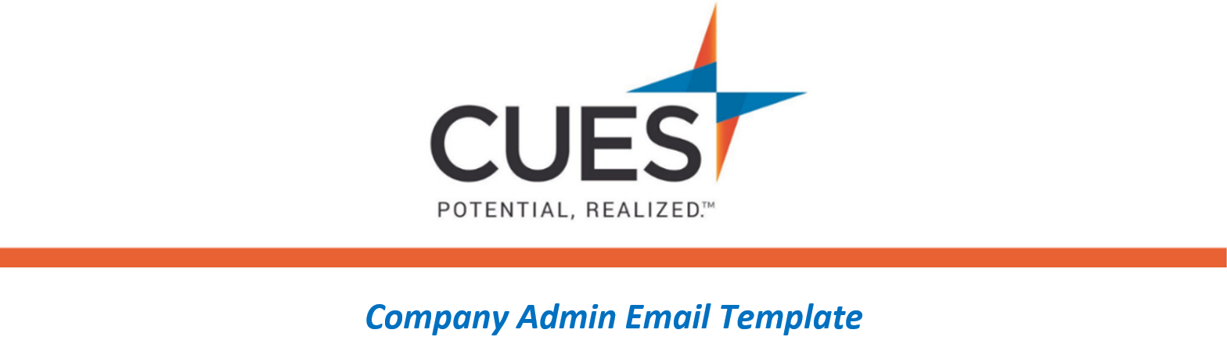
Event Registration – Paid Events

Purpose: Send to employees interested in paid events at CUES
Directions: Copy and paste the template below into a new email, replace all highlighted fields, then send

SUBJECT: CUES Event Registration – Paid Events
Hello <NAME>,
Thank you for your interest in attending <NAME OF EVENT>. Prior to registering, please be sure to review the attached registration policy for <CU/ORGANIZATION NAME>. Once you have obtained approval from management, register to the event using the Member Help Center guide below.
Event Registration
Once you have completed the registration you will receive a confirmation email from cues@cues.org. You will also be able to verify the registration in your events under “My Account Details”.
If you need assistance with registration, please email cues@cues.org with any questions.

