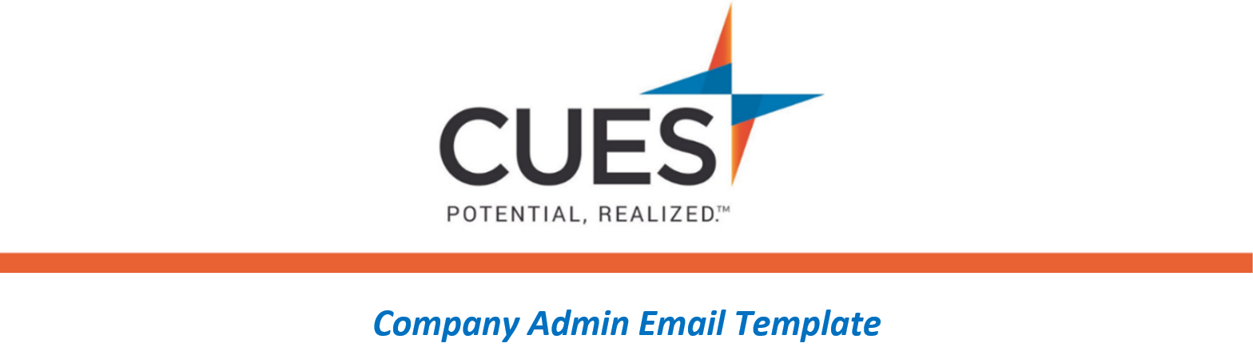
Benefit Overview - CUES Learning Portal

Purpose: Use this email template for those wanting to learn more about CUES Learning Portal.
*Admins, feel free to suggest a different pathway that aligns with your organizational goals.
Directions: Copy and paste the template below into a new email, replace all highlighted fields, then send

SUBJECT: Learn More about CUES Learning Portal
Hi <NAME>,
As part of your CUES membership, I encourage you to check out the CUES Learning Portal. The CUES Learning Portal is a blend of pre-set pathways and curated content, which offer an easy way to expand your skills in various business topics. These topics span from leadership and coaching to data science, strategy, and customer service.
The Introduction to Leadership pathway is a great place to start. At the end of each pathway, you can request a certificate of completion.
Access the CUES Learning Portal now or learn more here.
Be sure to check out the CUES Member Help Center to find CUES Learning Portal resources.

