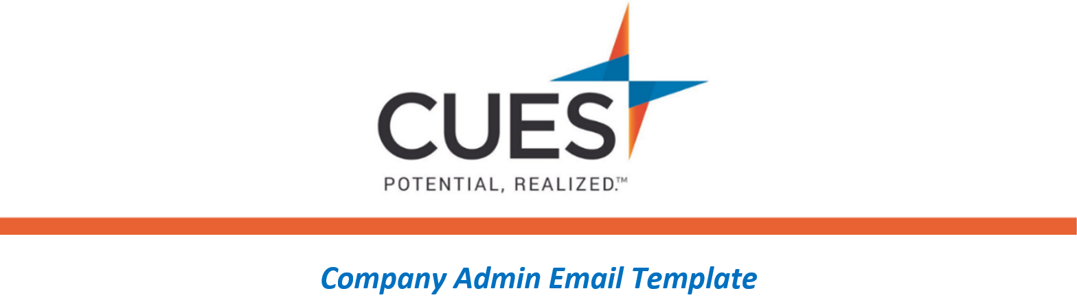
Welcome Email Follow-up (After given access to membership)

Purpose: Send to individuals interested in live learning with CUES Webinars
Directions: Copy and paste the template below into a new email, replace all highlighted fields, then send

SUBJECT: Learn More about CUES Webinars
Hi <NAME>,
As part of your CUES membership, you can register for CUES Webinars. Join these webinars live, monthly, or take advantage of the recorded webinars. These webinars will guide you on your membership journey and give you the tools you need to be successful within your membership and throughout your professional development.
You can participate in these webinars in real time or visit our webinar recordings, which are a great place to find an array of topics you might be interested in.
View upcoming webinars and recordings here.

