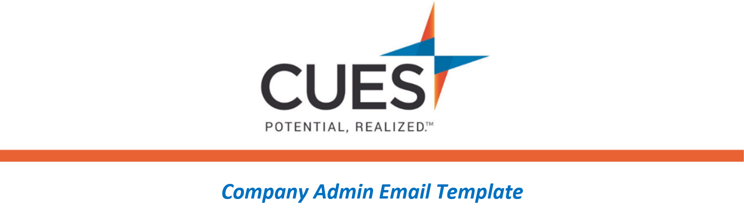
Welcome Email Follow-up (After given access to membership)

Purpose: Send 3 days after the welcome emails are sent from CUES
Directions: Copy and paste the template below into a new email, replace all highlighted fields, then send

SUBJECT: Take Advantage of your CUES Membership
Hello Team,
Your membership with CUES is now active! On <DATE> you should have received a welcome email from cues@cues.org. Please be sure to setup your password.
I will be sharing/assigning the <COURSE NAME> course with you today. To access the course, you’ll need to login to cues.org with the password you created.
<CU/ORGANIZATION NAME> is excited to provide this incredible resource just for you!
Be sure to check out the CUES Member Help Center to find additional resources within your membership.
If you have not yet received your welcome email from CUES, please contact them right away at 608.271.2664 opt. 2 or cues@cues.org.

