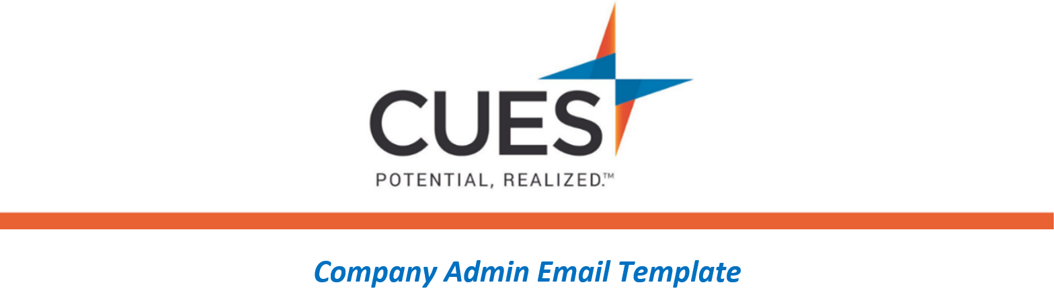
You’ve been assigned a CLP Pathway

Purpose: Send to individuals who have been assigned a CUES Learning Portal Pathway by your credit union
Directions: Copy and paste the template below into a new email, replace all highlighted fields, then send

SUBJECT: You’ve been assigned a CUES Learning Portal Pathway
Hello <NAME>,
<CU/ORGANIZATION NAME> has invested in your development by providing you with the resources included in your CUES membership. For your individual development we’ve identified the <NAME OF PATHWAY> pathway for you to complete.
In a few moments I’ll be assigning this pathway to you. You will receive an email from CUES, with a direct link to the pathway. Please have this completed by <DUE DATE>.
Don’t forget that you can request a certificate of completion once you have finished the pathway.
**Please note, you will need to be signed into cues.org to access this content. If you need help logging in or have forgotten your password, go to the Member Help Center and review the guide below.
Logging into CUES
Resetting Your Password

