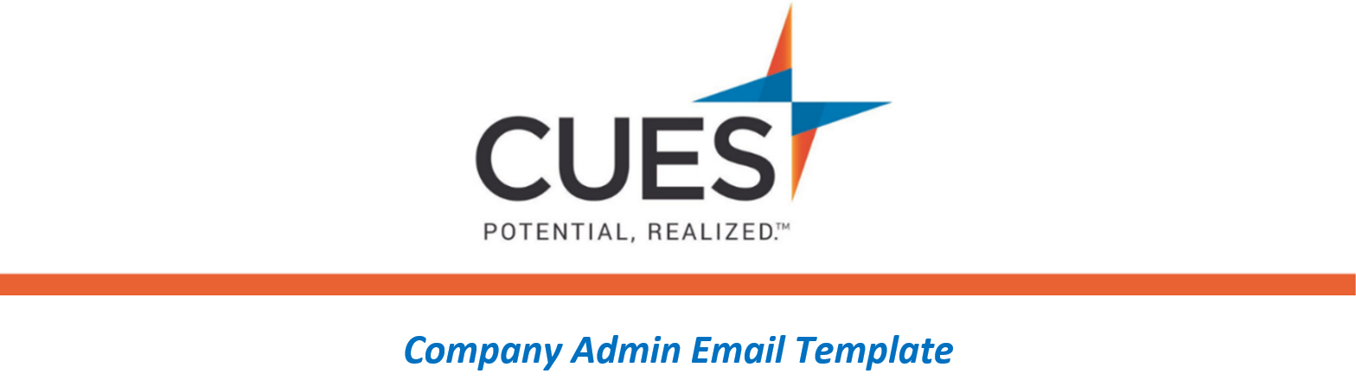
You’ve been enrolled in a CUES Learning Portal Course/Learning Journey

Purpose: Send to individuals who have been enrolled in a CUES Learning Portal course or learning journey by your credit union
Directions: Copy and paste the template below into a new email, replace all highlighted fields, then send

SUBJECT: You’ve been assigned a CUES Learning Portal Pathway
Hello <NAME>,
<CU/ORGANIZATION NAME> has invested in your development by providing you with the resources included in your CUES membership. For your individual development we’ve identified the <NAME OF COURSE OR LEARNING JOURNEY> course/learning journey for you to complete.
In a few moments I’ll be enrolling you into this course and/or learning journey. You will receive an email from CUES, with a direct link to the course and/or learning journey. Please have this completed by <DUE DATE>.
Don’t forget to download your certificate of completion!
**Please note, you will need to be signed into cues.org to access this content. If you need help logging in or have forgotten your password, go to the Member Help Center and review the guide below.
Logging into CUES
Resetting Your Password

