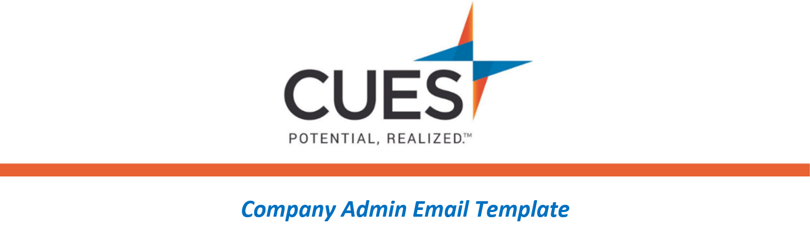
Benefit Overview - CUES Learning Portal

Purpose: Use this email template for those wanting to learn more about CUES Learning Portal.
*Admins, feel free to suggest a different course or learning journey that aligns with your organizational goals.
Directions: Copy and paste the template below into a new email, replace all highlighted fields, then send

SUBJECT: Learn More about CUES Learning Portal
Hi <NAME>,
As part of your CUES membership, I encourage you to check out the CUES Learning Portal. CUES Learning Portal offers a great way to stay current with your professional development, online. CUES Learning Portal includes curated content to expand your skill set with indivdiaul courses and learning journeys.
The Introduction to Leadership Foundations learning journey is a great place to start. At the end of each course, you can download a certificate of completion.
Access CUES Learning Portal directly from the myCUES Dashboard.
Be sure to check out the CUES Member Help Center to find CUES Learning Portal resources.

