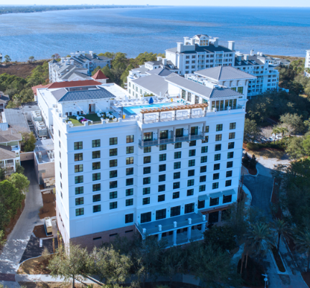
2026 FALL CONFERENCE

SPONSORSHIP OPPORTUNITIES

Hotel Effie • Sandestin, Florida • October 14–16, 2026
Network with credit union professionals, showcase your brand, and enjoy the camaraderie of the Florida CUES community.
Held in conjunction with the Joint Chapter Charity Scramble Golf Tournament at The Links Golf Club on October 16, 2026.
Hotel Website: www.hoteleffie.com Conference Room Rate: $245/night Discount Code: FCU
SPONSORSHIP LEVEL | DETAILS
Welcome Reception Sponsor – $3,000 (Exclusive) | Baytowne Marina Welcome Reception • • Reception signage • Recognition during opening remarks • 3 attendee registrations
Lunch Sponsor – $2,000 (Exclusive) | Conference Lunch • Company introduction opportunity • Table signage • Logo on conference marketing • 2 attendee registrations
Breakfast Sponsor – $1,500 (Exclusive) | Conference Breakfast • Table signage • Logo on conference marketing • 1 attendee registration
Conference Refreshment Sponsor – $1,000 (2 Available) | Coffee & refreshment breaks • Refreshment station signage • Recognition during conference announcements
General Conference Sponsor – $500 | Logo included on conference marketing and conference recognition

PAYMENT INFORMATION
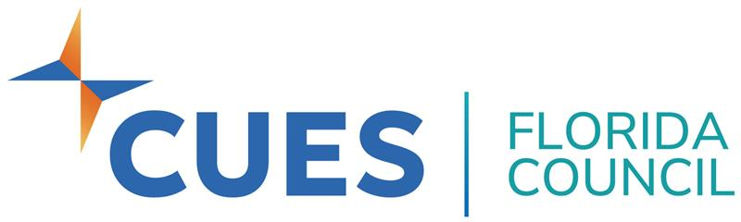
FL CUES Council
c/o Kenny Ray Mitchell
Innovations Financial Credit Union
P.O. Box 15529 • Panama City, FL 32406
krmitchell@innovationsfcu.org • 850-832-3872

